PROJECT REPORT

Name - Priyanka Maru (202091536)

Main goal - How can the company be improved?

Subgoal 1 - **Promoting the jobs which are more profitable**. -Net Profit for each job = Invoice amount - material costs - wages of the employee for that job (considering the employee has worked for 4 hours in a day)

Subgoal 2 - **Improvement of the customer satisfaction**.

The above visualization helps us understand the average customer satisfaction for each job type. If the Customer is highly satisfied as seen in case of garden beds job or else customer is not satisfied as seen in retaining wall job. We could have an idea as to which jobs to focus on and needs more improvement.

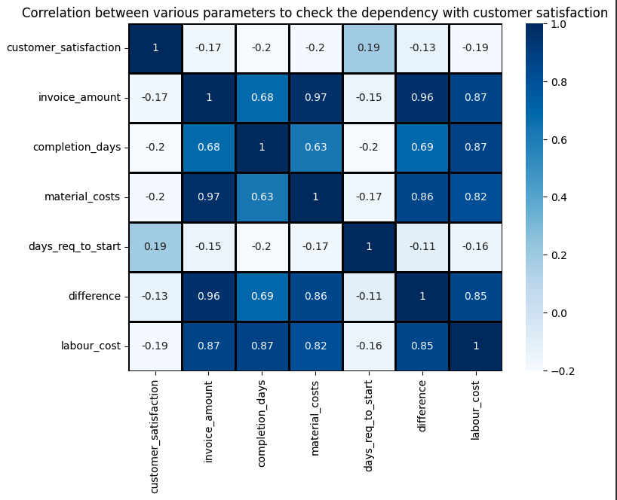

The above Visualization shows the correlation between different parameters which will help us analyse if any feature is corelated to customer satisfaction feature, so that the customer satisfaction can be improved. The correlation between the features will help us understand and evaluate which feature is related to customer_satisfaction feature. As seen from the visualization, days_req_to_start is related to customer satisfaction with a correlation of 0.19, which is not very closely related but still related to the customer satisfaction feature.

The new derived features are:

completion_days: period between the start date and completion date in days.

days_req_to_start: period between the request date and completion date in days.

difference: difference between invoice_amount and material_costs

labour_costs : the wages of the employees for that particular job

Interactive Visualization: This data visualization which is a line plot helps us to understand the relation between customer_satisfaction and days_req_to_start features, as the days_req_to_start feature is seen to be correlated to customer_satisfaction feature with the correlation index as 0.19. The understanding of this relation helps us get an idea if response time is the reason for lower or higher customer satisfaction for jobs. As seen, the data is quite cluttered in the line graph so we can use the dropdown to select the required job type which will be highlighted in the graph and then can be further compared.

As seen in the above visualization, the “basic lawncare” job is selected form the dropdown and is highlighted in the line graph. We can say, most of the job type requests have been answered on an average within 10 to 25 days and it is seen that the customer satisfaction is quite good in that range.

As seen in the above visualization, the “garden bed” job is selected form the dropdown and is highlighted in the line graph. We can say, in case of garden beds job _type the average response time ie in the range of 22 days to 27 days (on an average). The average customer satisfaction is the highest when the average response time is between 25 to 30 days.

Thus, we can conclude that the average customer satisfaction is high in those cases when the average response time is in the range from 15 days to 25 days (approximately) excluding the two job_types which are basic_lawncare and complete_lawncare which have a higher customer satisfaction rate when the average response time is beyond 30 days.

Interactive Visualization: This visualization is a bar plot of Profit per job. It helps us understand which jobs are more profitable so that we promote those jobs and improve the company. The visualization consists of filtering the bar plot as per the chosen customer type. If “Commercial” is selected, the plot will display the profit per job_type only for Commercial customer_type and if “Residential” is selected, the plot will display the profit per job type only for Residential customer_type and if “Commercial” and “Residential” both are selected, the grouped bar plot will display the profit per job type for both Commercial and Residential customer_type.

Assumption: For calculating the wages of the employee, it is considered that the employee has worked for 4 hours each calendar day on a job.

The above visualization shows the profit per job_type for Commercial customer_type. As seen, basic lawncare job_type has the maximum profit of $24000 (approximately) amongst all the job_types for commercial customers.

The above visualization shows the profit per job_type for Residential customer_type. As seen, basic_lawncare job has the most profit of $32000 (approximately) amongst all the other jobs incase of Residential Customers.

The above visualization shows the profit per job_type for Commercial and Residential customer_type. As seen, basic_lawncare job has the most profit of $24000 and $32000 (approximately) amongst all the other jobs incase of Residential and Commercial Customers respectively. So, by looking at the plot, we can promote basic_lawncare, water_feature, garden_beds and complete_lawncare jobs as they are the most profitable amongst all other job_types in both Residential and Commercial customers.

Video Presentation link: